**What is BFS?**

**Breadth-First Search (BFS)** is a fundamental graph traversal algorithm commonly used in Artificial Intelligence (AI) and computer science. It systematically explores nodes layer by layer: it visits all the neighbors of a starting node before moving on to the next level of nodes. BFS guarantees finding the shortest path in an unweighted graph, making it ideal for applications like puzzle solving, pathfinding, and network analysis

**BFS is a powerful, simple algorithm ideal for exploring all possibilities level by level and for cases where the shortest solution is required.** It is fundamental to many AI problem solvers and essential in computer science curricula

**Key Properties:**

* **Completeness:** BFS will always find a solution if one exists in a finite graph.
* **Optimality:** Finds the shortest path (least number of steps) in unweighted graphs.
* **Time Complexity:** O(V+E)*O*(*V*+*E*), where V*V* is the number of vertices and E*E* is the number of edges.
* **Space Complexity:** Potentially high as it stores all nodes at the current level in a queue.

**How BFS Works**

1. **Start** at the root node (or any arbitrary node in the case of a graph).
2. **Visit all its adjacent nodes** and mark them as visited.
3. **Enqueue** these visited nodes.
4. **Repeat** the process: for each node in the queue, visit all their unvisited neighbors, mark them visited, and add them to the queue.
5. **Continue** this process until the goal is found or all nodes are visited.
6. **Queue** data structure ensures nodes are explored in a first-in, first-out (FIFO) order.

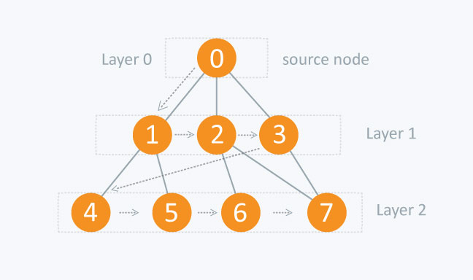

| **Application Area** | **Real-Time Impact** |
| --- | --- |
| Network Routing | Finds shortest paths for data packets, live routing updates |
| Social Networks | Instant mutual friend search, real-time recommendation, influencer detection |
| Broadcasting | Rapid distribution of data to all devices in a network |
| GPS & Robotics | Live shortest-path navigation and dynamic re-routing |
| Web Crawling | Real-time discovery and indexing of new content |
| Game AI | Instant decision-making and pathfinding |
| Recommender Systems | On-the-fly product/content suggestions by exploring similarity graphs |
| Network Security | Live mapping and monitoring of enterprise networks for threats and vulnerabilities |